Buy America Exemption – Example DT1310 (NER22-0621)

* **Bid Item Name:**

Buy America Exemption (Allowable: $2500.00)

* **Quantity Involved:**

Enter dollar amount of non-complying steel/iron (ie: amount claiming under the exemption)

* **Units:**

DOL

* **Test Results:**

Buy America documentation was not provided.

* **Spec Requirements:**

All steel / iron need Buy America certification per 23 CFR 635.410

* **Disposition Explanation:**

*Example:*

637.22XX Signs Type II - Mounting Hardware

3/8"x3" Lag Screws w/ 3/8" Nylon Washers ($14.20)

3/8" Steel Washers ($4.26)

653.01XX Pull Boxes - Hardware

3/8"x2" Lag Screws ($60.96)

656.0200 Meter Breaker - Hardware

Screws & Fasteners ($4.47)

657.07XX Luminaire Arms Truss - Hardware

1/2"-13x2 1/2" Hex Cap Screws ($312.32)

1/2" Washers ($84.48)

1/2" Nuts ($76.80)

1/2" Lock Washer ($48.64)

Total allowable exemption amount = $2,500.00

Total amount logged under exemption = $606.13

All items are logged on Buy America Exemption Report and have material invoice documentation. Documents are located in material archive with DT4567 Buy America Certification Form

* **Placement Date:**

Leave Blank

* **Sample Date:**

Leave Blank

* **Sample Location:**

Leave Blank

* **Usage:**

Project Wide

* **Usage Location:**

Project Wide

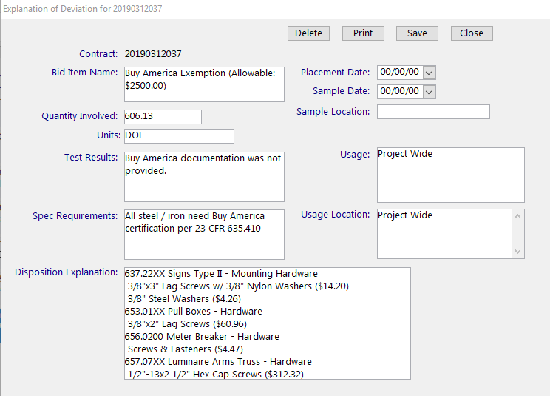

Figure: MIT Entry Buy America Exemption Example

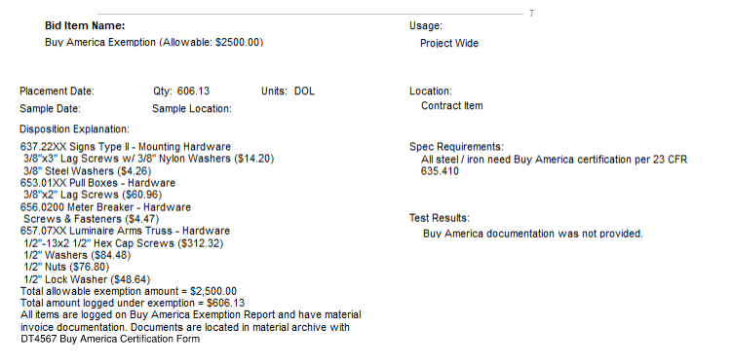

Figure: Printed DT1310 Buy America Exemption Example